**PRN : 117A1002**

**EXPERIMENT:**

**AIM:**  To implement WEKA Tool for classification and clustering.

**THEORY:**

Weka is a comprehensive software that lets you preprocess the big data, apply different machine learning algorithms on big data and compare various outputs. This software makes it easy to work with big data and train a machine using machine learning algorithms.

Weka tool will be used to perform clustering and classification for the following experiment

**SNAPSHOTS:**

1. **Preprocessing:**

**WEKA Explorer:**

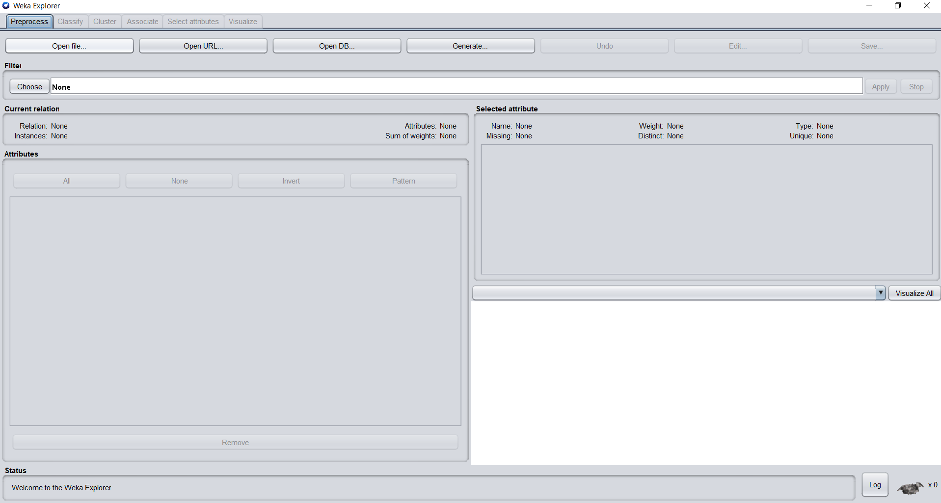

**Load the weather nominal data:**

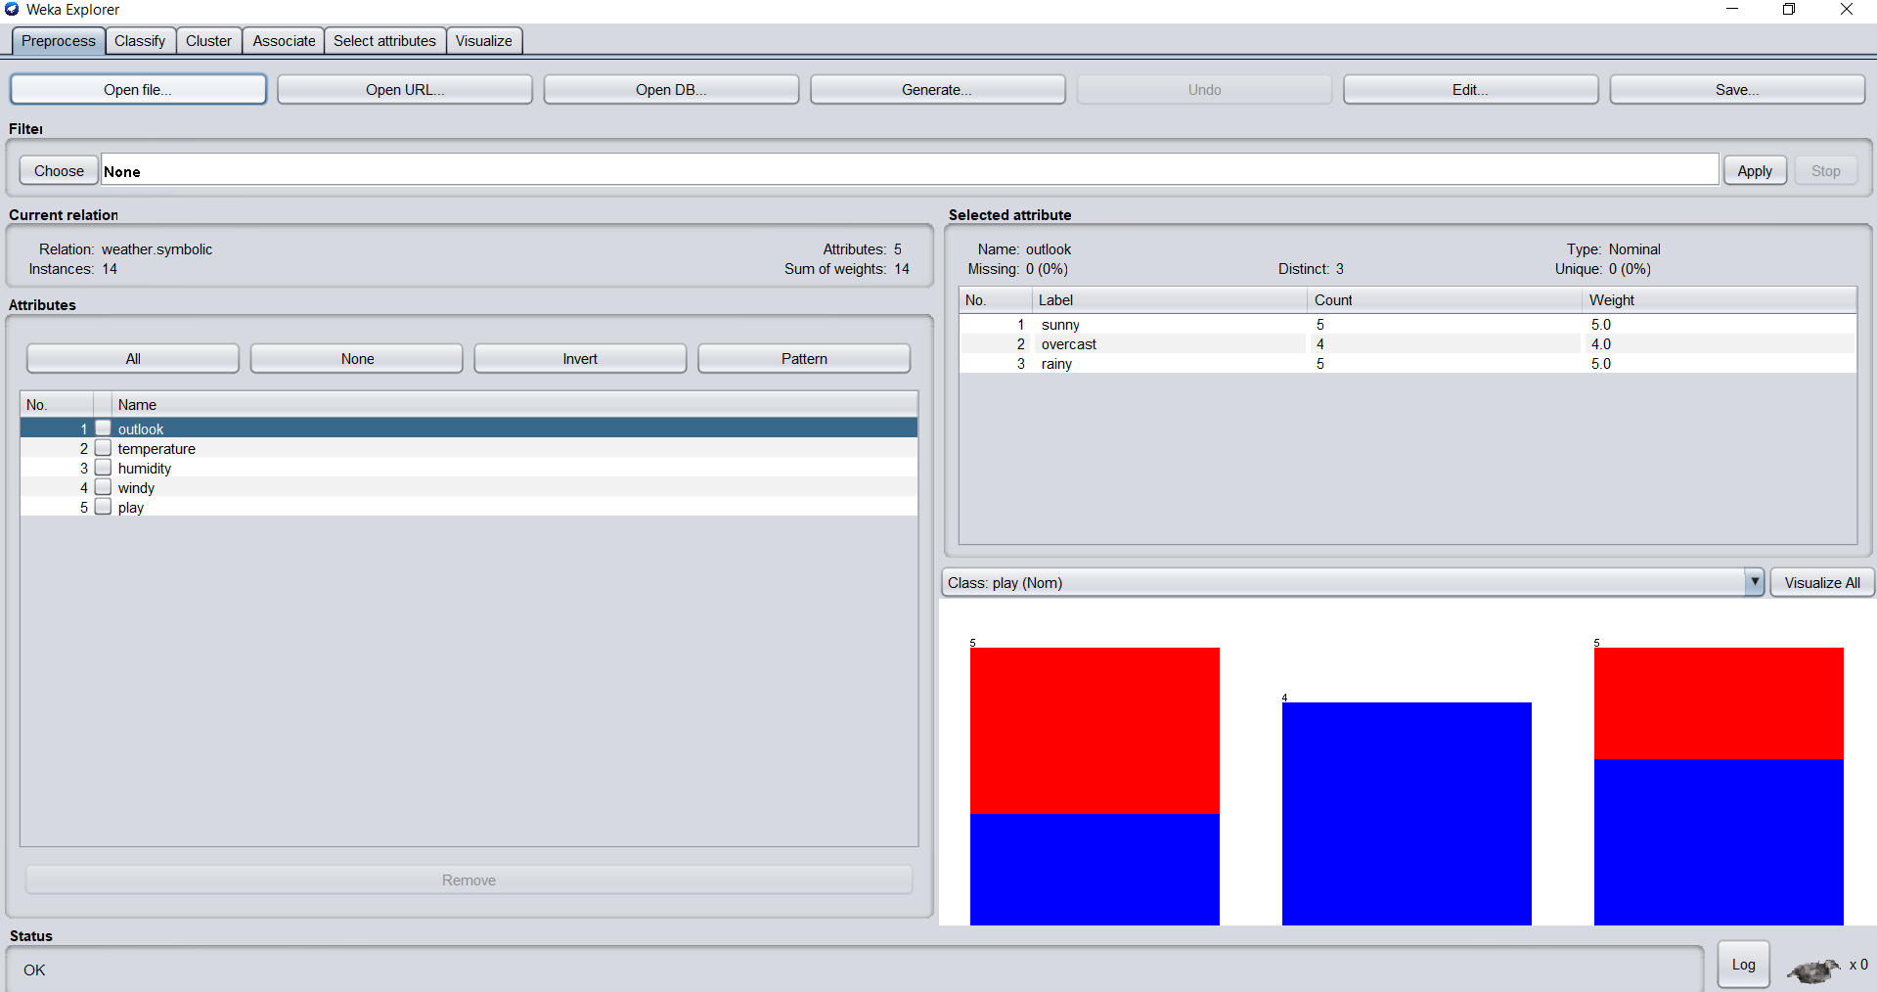

**Visualizing all the attributes:**

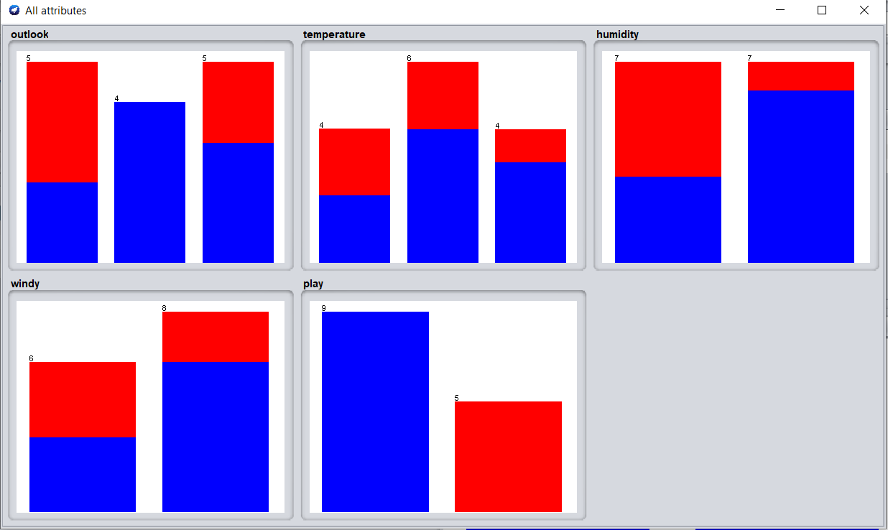

**Remove the attributes - temperature and humidity:**

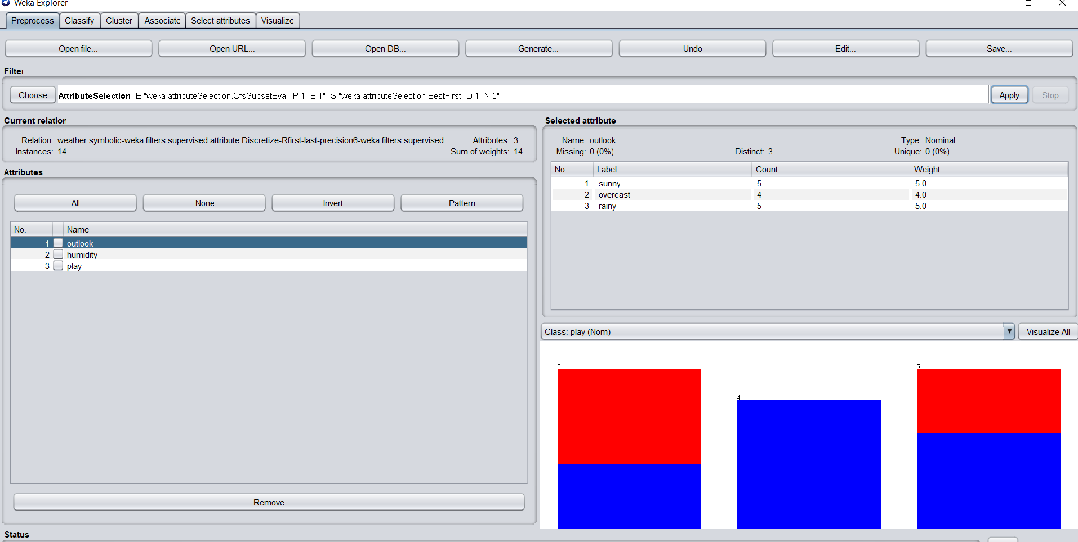

1. **Classification**

**Selecting J48 algorithm for classification:**

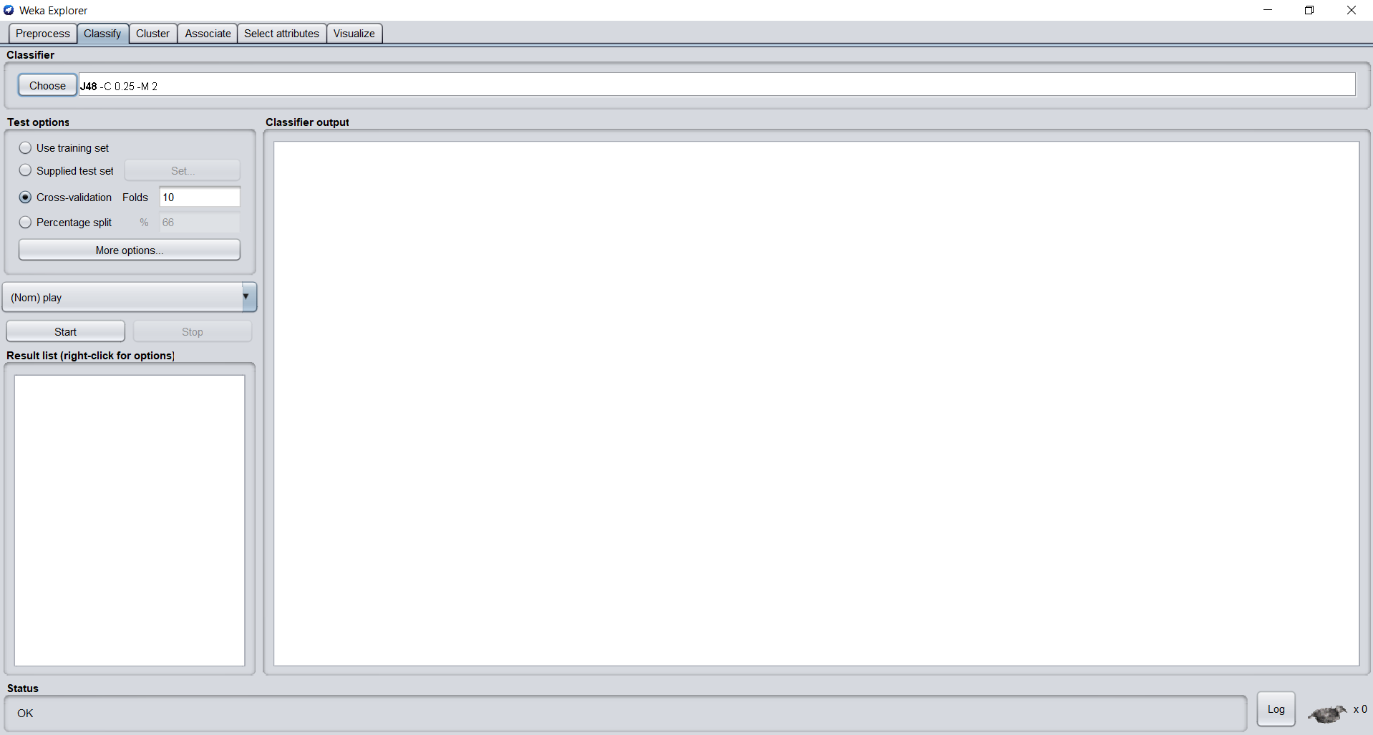

**Output of classification:**

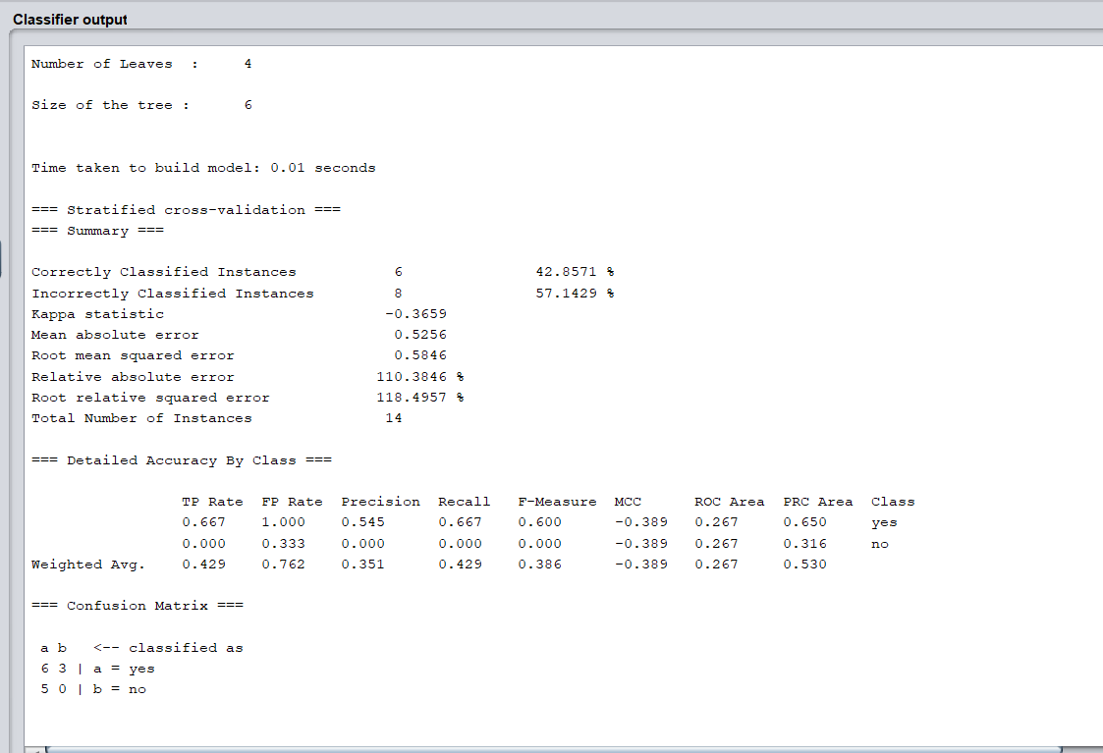

**Classifier Output Visualizer of J48 :**

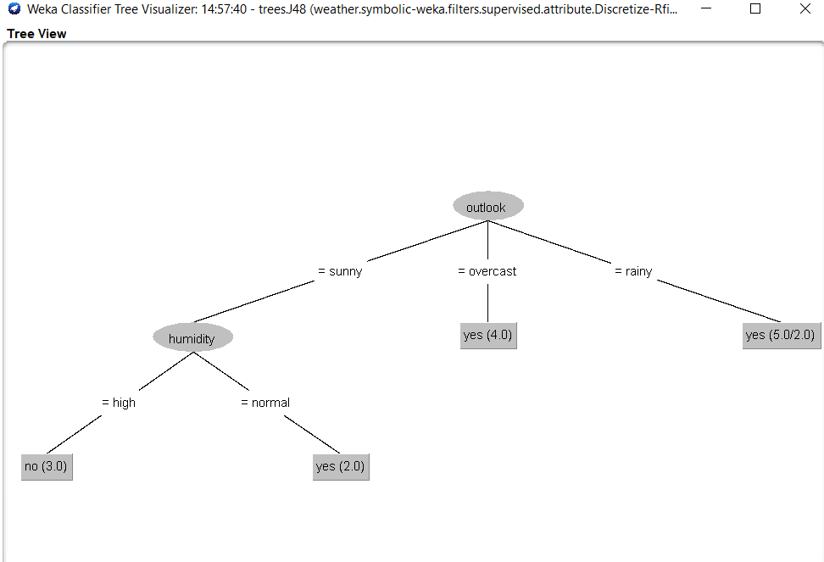

**Visualize errors:**

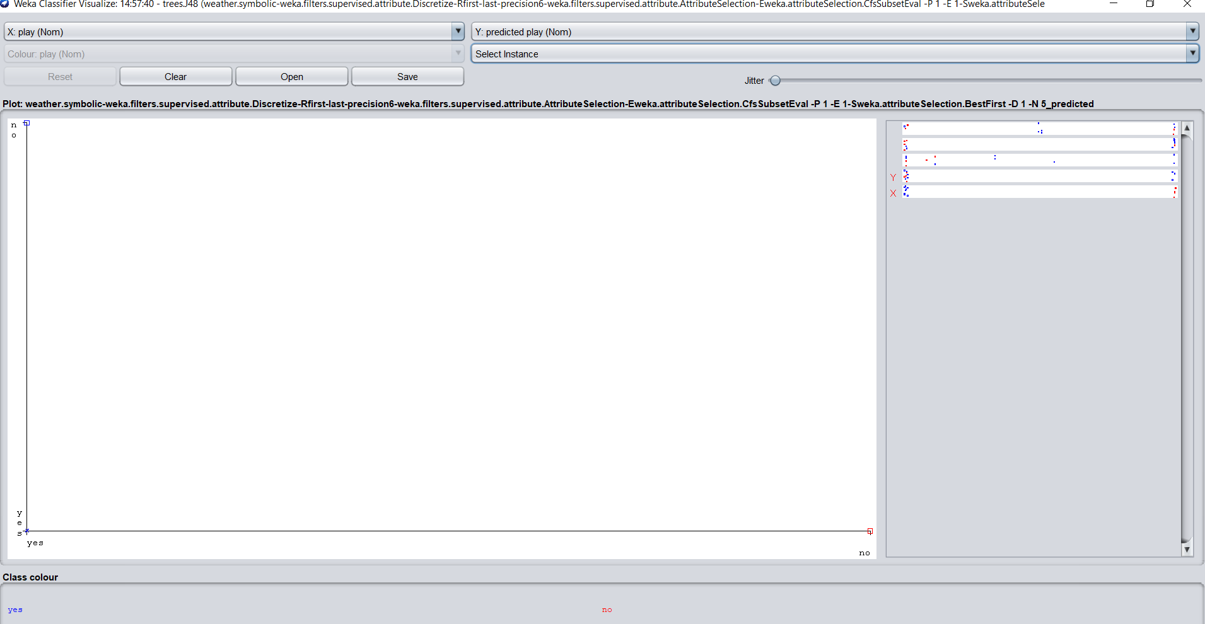

**Cost/ Benefit Analysis**

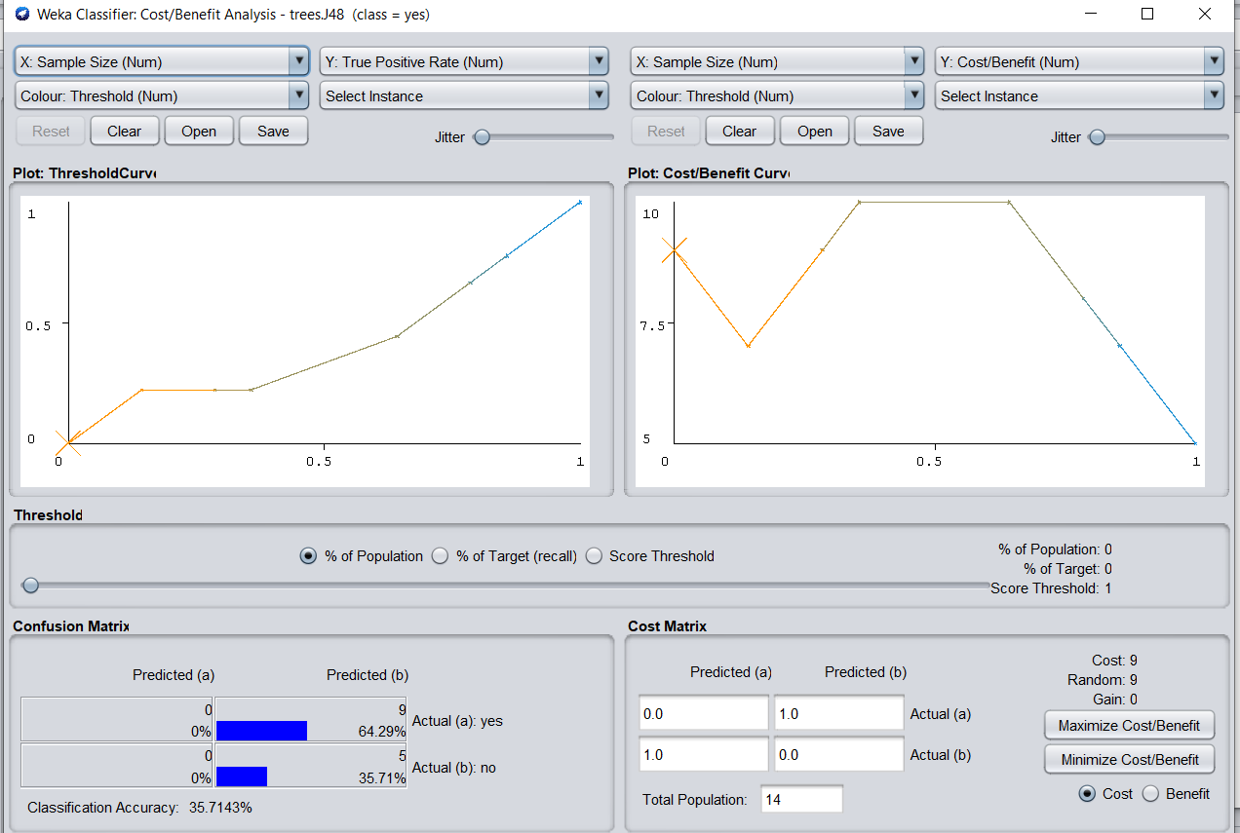

1. **Clustering**

**Output of K Means:**

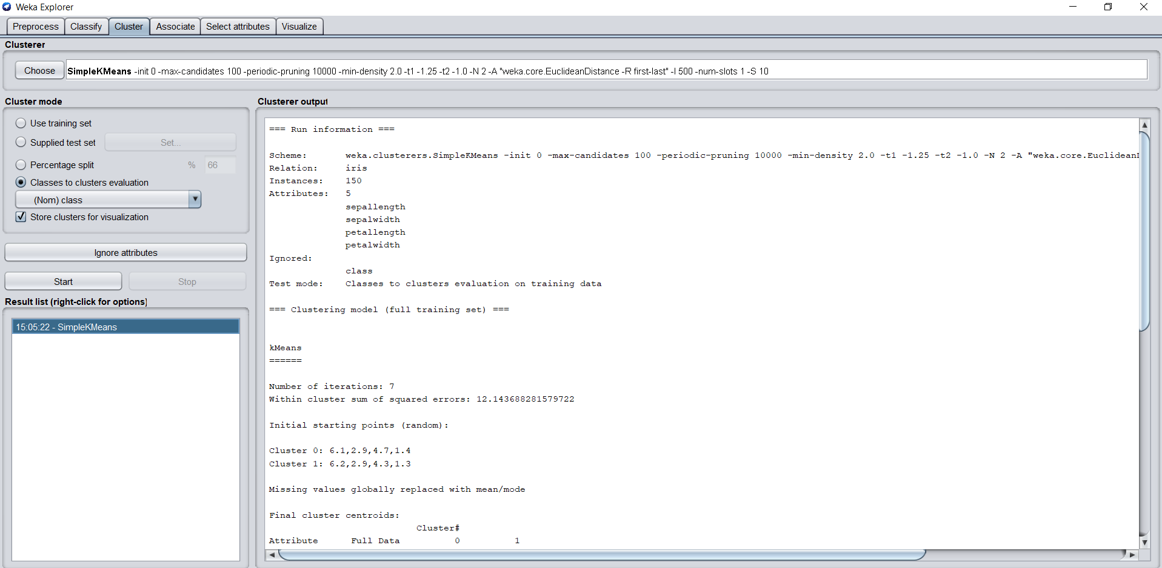

**Visualization of K means:**

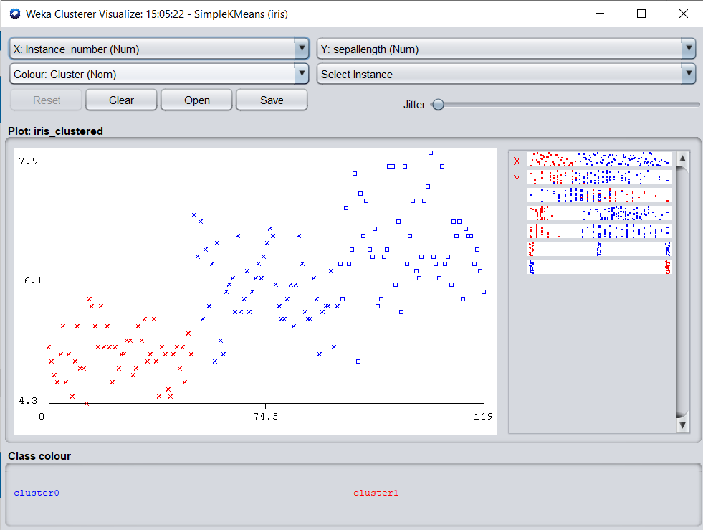

**Output of Hierarchical Clustering:**

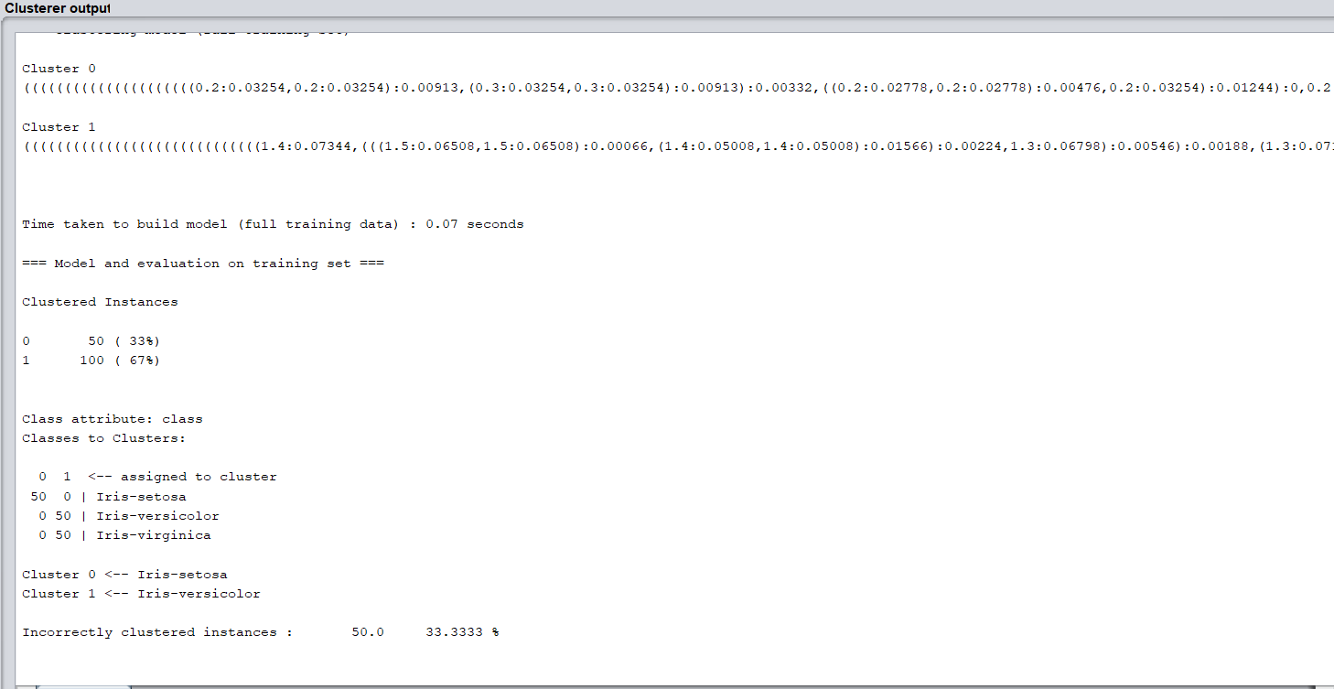

**Visualization tree of clustering**

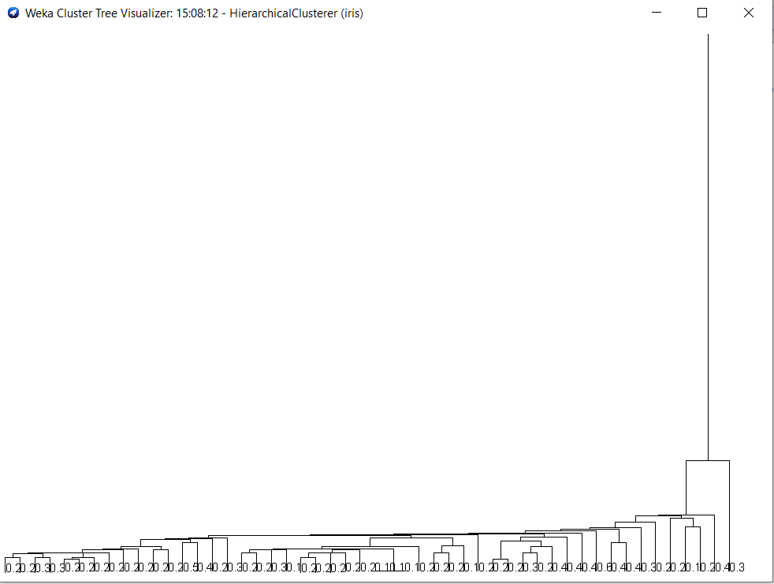

1. **Association**

**Loading the supermarket data**

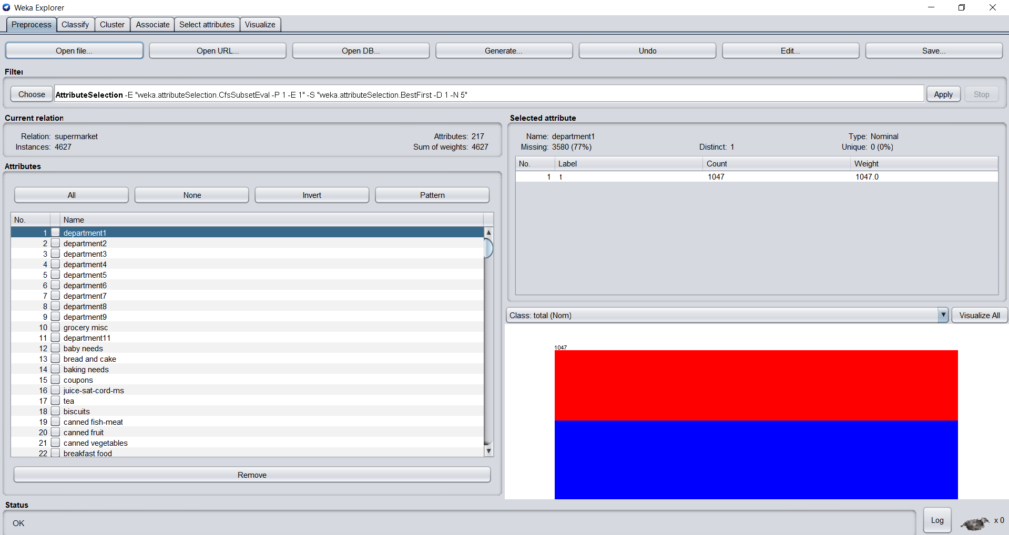

**Using Apriori Algorithm**

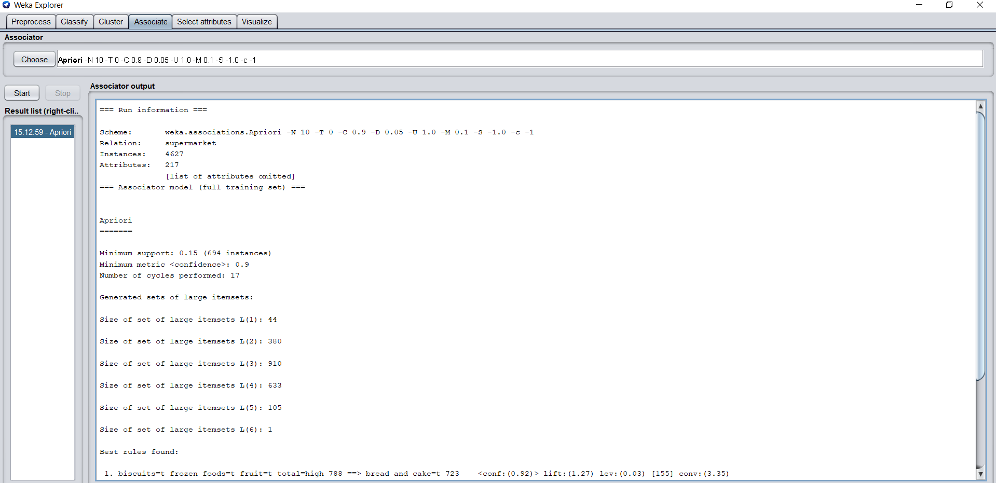

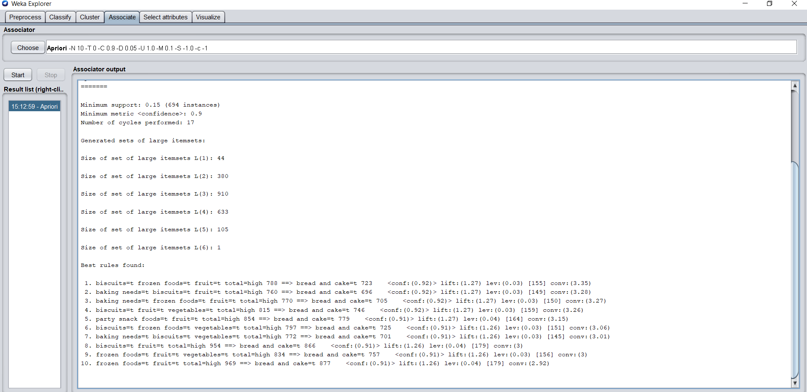

**CONCLUSION:**

**Thus, WEKA tool has been explored and implemented.**